Title of the article

First Author1, Second Author2, and Third Author3

1Department, University, City, Country (E-mail: ﬁrstauthor@email.com)

ORCID: 0000-0000-0000-0000

2Department, University, City, Country (E-mail: secondauthor@email.com)

ORCID: 0000-0000-0000-0000

3Department, University, City, Country (E-mail: thirdauthor@email.com)

ORCID: 0000-0000-0000-0000

**Abstract**

This paper covers how to format your paper files in the manuscript you will provide to Taylor & Francis. It covers manuscripts supplied in Microsoft Word format. The paper includes all the basics; the first section covers the text itself and is essential to all books. It emphasises that Taylor & Francis do not have a set house style, but instead require consistency throughout in terms of stylistic choices including spelling and referencing. It also includes guidance for including abstracts, such as the present one, and keywords, as below. The second section includes information on non-textual content and how this is indicated and referred to in the paper itself, with specific guidance on callouts and captions.

The paper text as it will appear in the book then begins here. Note that the purpose of this sample is to show how to include the various aspects outline above including abstracts, keywords, tables, figure callouts and special characters. The actual formatting in terms of line spacing and font size etc. only needs to be clear and consistent rather than following any requirements.

**Keywords and phrases:**

**1 Introduction**

Your Text here

**2 Equations**

Let us see how easy it is to write equations with help of MathType 6.0 equation editor.

. (1)

It is a good idea to number equations, but we can have a equation without a number by writing

.

**3 Tables**

You may choose to refer to tables in the text, such as table 1.1.[1] Note that the table has been added using the insert table functionality within Word, rather than being an image pasted into the document. Because this is created using Word and is fully editable, it is fine to include in the manuscript itself.

|  |  |
| --- | --- |
| State | Abbreviation |
| Alabama | AL |
| Alaska | AK |
| Arizona | AZ |
| Arkansas | AR |
| California | CA |

Table 1.1. Some U.S. states and their abbreviation

**4 Lists**

Some example of formatted lists includes the following:

1. bread
2. cheese

* Tom
* Dick

**5 Figures**

We can make figures bigger or smaller by scaling them. Figure 1.1 has been scaled by 60%.

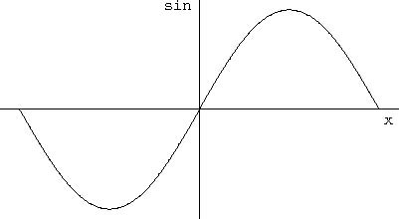

Figure 1.1. Show me a sine.

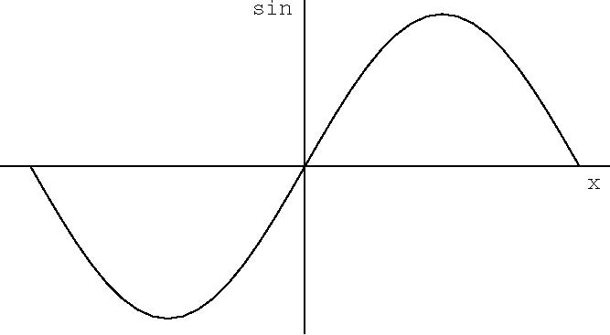

Figure 1.2. Plot of the Lennard-Jones potential . The potential is characterized by a length  and an energy *Q*.

**Acknowledgement**

Detail of research grants etc. ..........

**References**

Herodotus, *Histories*, trans. A. D. Godley. Cambridge: Harvard University Press, 1920.

Taylor & Francis, ‘Manuscript writing and formatting guide’. Taylor & Francis, 2021. <https://www.routledge.com/our-customers/authors/publishing-guidelines>

1. Note that the table is referred to by number, rather than just ‘below’. See Taylor & Francis, ‘Manuscript writing and formatting guide’ (Taylor & Francis, 2020).